Homework 3
VQ and DCT Implementation
The objective of this assignment is to understand and implement one of the following image compression techniques — Vector Quantization (VQ) or Discrete Cosine Transform (DCT) — in order to strengthen your knowledge of image compression methods.
Option 1—Discrete Cosine Transform
You are required to apply the Discrete Cosine Transform to grayscale images and implement it in Python, you can use OpenCV’s DCT function, or you can design an algorithm according to the formula below and documenting all your observations in the report.
$$2D DCT: F\left(u,v\right)= \frac{2}{N}C\left(u\right)C\left(v\right)\sum_{y=0}^{N-1}{}\sum_{x=0}^{N-1}{}f\left(x,y\right)coscos \left[\frac{\left(2x+1\right)uπ}{2N}\right] coscos \left[\frac{\left(2y+1\right)vπ}{2N}\right]$$
$$2D IDCT: F\left(u,v\right)= \frac{2}{N}\sum_{y=0}^{N-1}{}\sum_{x=0}^{N-1}{}C\left(u\right)C\left(v\right)F\left(u,v\right)coscos \left[\frac{\left(2x+1\right)uπ}{2N}\right] coscos \left[\frac{\left(2y+1\right)vπ}{2N}\right]$$
$$\{C\left(u\right),C\left(v\right)=\frac{1}{\sqrt{2}} for u,v=0 C\left(u\right),C\left(v\right)=1 otherwise$$
In addition, please perform simple frequency-domain filtering. Since the DCT compacts most of the energy into the upper-left corner of the coefficient matrix, crop this region (size is arbitrary) and observe the reconstruction quality after applying the inverse DCT.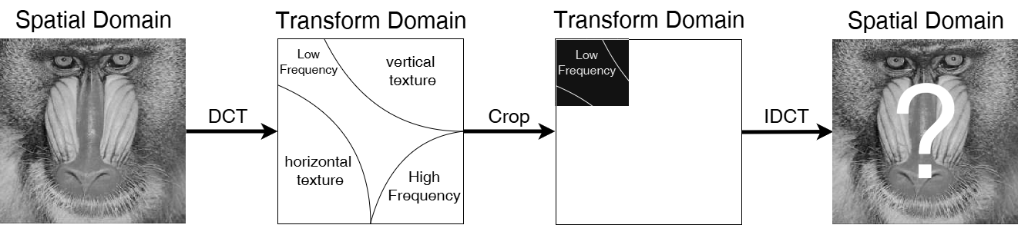
It was mentioned in class that DCT can be decomposed into Fast DCT, and if you manage to implement this, you will receive a higher score.
Option 2—Vector Quantization
In this part, you are required to implement Vector Quantization using the Linde–Buzo–Gray (LBG) algorithm, as described in Chapter 7, Slide 46 of the lecture notes.
The image should be divided into fixed-size blocks (e.g., 4×4 or 8×8), each block reshaped into a vector, and a codebook should be generated through the iterative clustering process defined by LBG.
After the codebook is built:
- Each image block is encoded by the index of its nearest codeword.
- The reconstructed image is obtained by mapping each index back to its corresponding codeword.
Please include your VQ results, reconstructed images, and observations in the report.
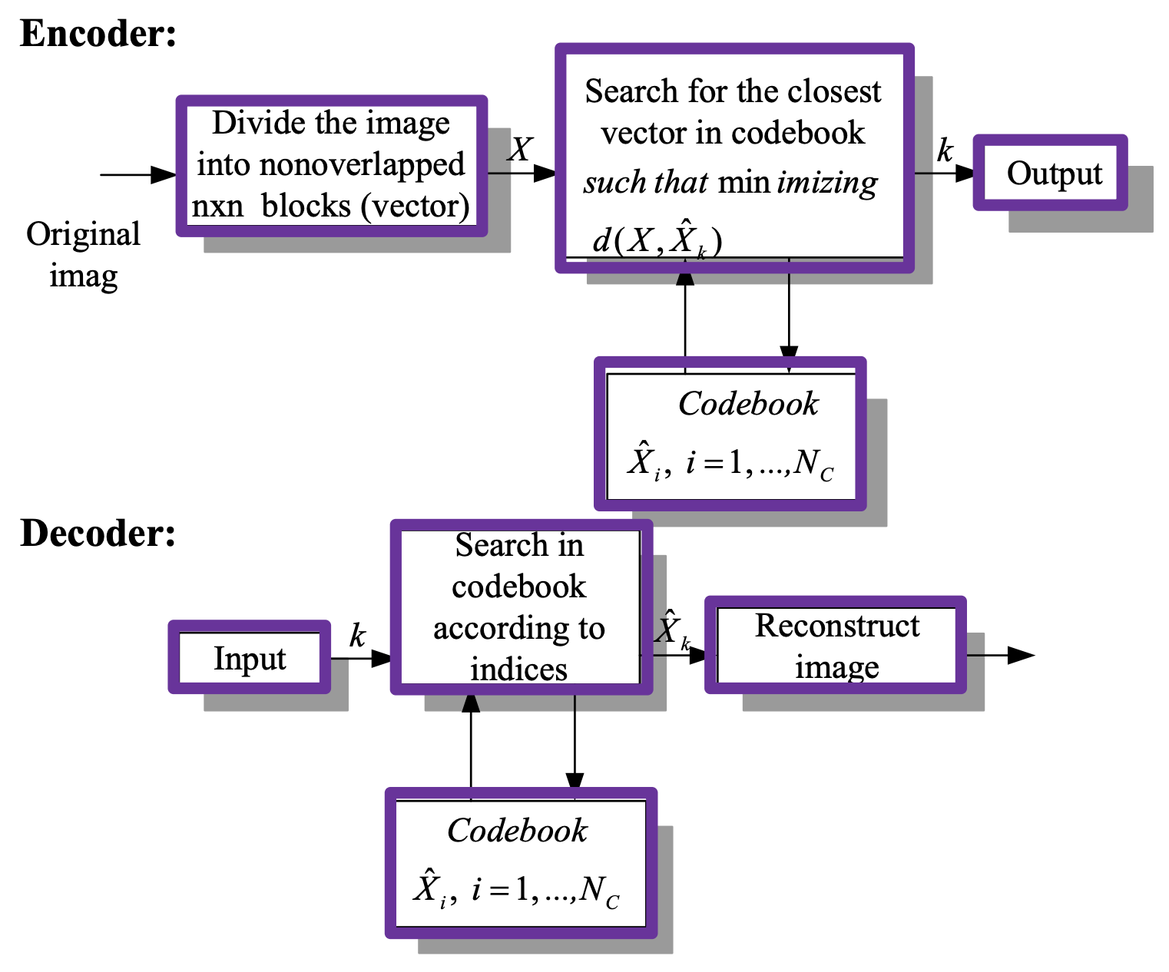
The report must contain the following(Submit the PDF)：
- Results (Choose one of the two options below; completing both will earn extra credit)
  - DCT
    - Original grayscale image
    - DCT image in the frequency domain
    - Image after inverse DCT reconstruction
    - Image after frequency-domain cropping and inverse DCT
  - VQ
    - Original grayscale image
    - Reconstructed image using VQ
    - A table screenshot listing each codeword vector
- Explain：Your method (if you have other try) with experiment
- Discussion：Interesting finding, difficulties you encountered, insights you observe.

